**SENTIMENTAL ANALYSIS :**

**Turi Use case :** <http://jmcauley.ucsd.edu/data/amazon/>

<https://www.kaggle.com/archaeocharlie/comcastcomplaints>

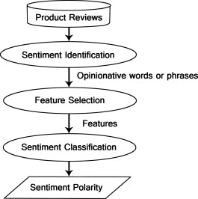

**APPLICATIONS :**

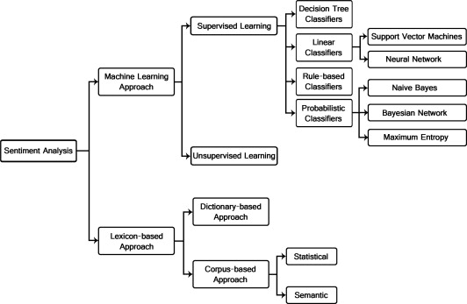

* **Twitter Sentimental Analysis**
* **Inform and make operational improvements or capital expenditures :** With the Sentiment Analysis report, a hotelier could look at a recent time period and identify topics that were mentioned most frequently with a negative sentiment attached. In the topic cloud below, the topics that came up most frequently are “room odor,” “noise,” and “bathroom condition.” With this information, a hotel would know to evaluate these areas when it comes time to make decisions about property improvements.
* **Evaluate guest likes and dislikes for your property AND your competitors’ properties :** Amplify your superpower spy skills. Take what you learned above about identifying strengths and weaknesses and apply that intelligence to your competitors as well. If you know that you have frequent negative mentions of your room service quality, but your competitors tend to have high mentions of their food and beverage topics, you can consider this a particularly important topic to investigate further. On the flip side, if you have some trending topics that are positive for your property, but not as popular for your competitors, consider highlighting those in your sales and marketing materials.

### **Apply Sentiment Analysis for surveys :** Use your Sentiment Analysis results to optimize your survey. For example, if you’ve determined that housecleaning speed of service is something that is mentioned frequently in your reviews and surveys, then probe further on this topic. Adjust your survey on your own with our simple-to-use, self-service tools.

* <https://www.lexalytics.com/applications>
* <https://dzone.com/articles/sentiment-analysis-concept-analysis-and-applicatio>
* Sentiment analysis could also be applied to your corporate network, for example, by applying it to your email server, emails could be monitored for their general “tone”. For example, [Tone Detector](http://tonedetector.com/) is an Outlook Add-in that determines the “tone” of your email as you type. Like an emotional spell checker for all of your outgoing email.
* Business value of Sentimental Analysis :**Enhancing the customer experience, Gaining competitive advantage, Gaining Business Intelligence**
* <http://www.analytos.com/usecases.php>
* **Sentiment Analysis as-a-Service :** Companies such as Microsoft, IBM and smaller emerging companies offer REST APIs that integrate easily with your existing software applications.
* **IBM Watson :** At the enterprise level, IBM’s Watson [Tone Analyzer](https://tone-analyzer-demo.mybluemix.net/) introduces additional emotive states and attempts to identify feelings such as “anger”, “joy” and “agreeableness” – as well as the regular positive/negative states.

<https://www.growthaccelerationpartners.com/blog/sentiment-analysis/>

* One of the most important areas for sentiment analysis, and social media monitoring in general, is bridging the gap between insight and action. It's one thing to retrieve a sentiment pie chart. It’s another to masterfully place it within the context of your brand’s social media performance.

<https://mashable.com/2010/04/19/sentiment-analysis/#Ofaz6BqLJ5qm>

* Political Polling/Analysis
* Real-time Political Analysis : Data-driven media and journalism , PR management for political figures and parties
* In Finance, it helps in aiding decision-making for financial traders and analysts .How do you know if others are fearful or greedy? Well, if you are aware of the sentiment analysis technique, you can have a fair idea. Let’s take an example of the automobile industry. If you are confused about whether to invest in Company A or in Company B. Look for the sentiments received by their latest car models. You will know which one of these is performing better in the market. And now you know, which of these companies is worthy of your shares.